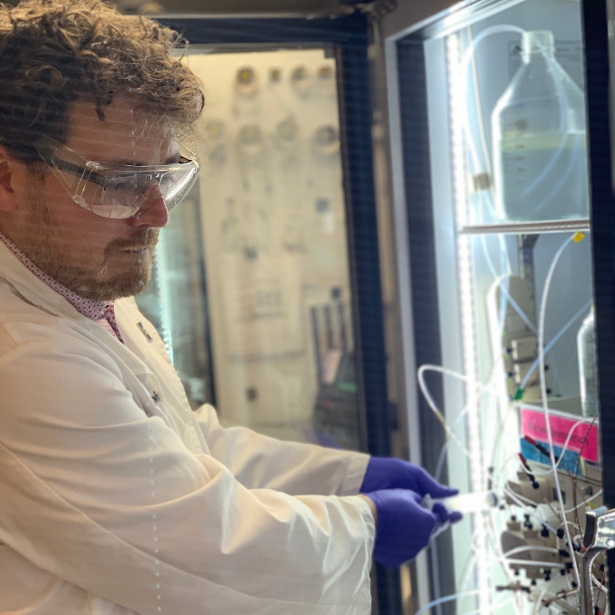
Kris Grohn, Graduate Research Assistant, Biochemistry Graduate Student
My previous work at Ichor examined the claims that administration of buckminsterfullerene in an olive oil solution leads to mammalian life extension. Buckminsterfullerene (also known as C60), is a molecule composed of 60 carbons which form a soccer ball like spherical structure. Carbon molecules link to each other in a matrix throughout the molecule, which give it interesting characteristics such as the ability to absorb free radicals and to appear as a red, wine-like color in solution. During our initial investigations, however, we became concerned with the quality of C60 that was being provided to people on the open market, specifically through online vendors. In a series of studies, I investigated the quality, health effects, and characteristics of C60 which being sold. The results of this research are being finalized and will be submitted for peer-review this year.
Beyond work with specific molecules like C60, Ichor is working to target each of the hallmarks of aging with specific interventions. The primary focus of my graduate work has been advancing Ichor’s flagship intervention for age-related macular degeneration (AMD). AMD is characterized by lysosomal dysregulation, driven by the accumulation of indigestible retinoid-based waste products that clutter the lysosome and inhibit native degradative processes. Our approach to this problem is an enzyme augmentation therapy (EAT) which introduces a recombinant enzyme that is capable of degrading the indigestible waste products in the lysosomes of affected cells. Our early proof-of-concept work on this program was published in late 2018 and demonstrated that this approach is efficacious in a mouse model of AMD. Since then, my emphasis has been on formulating the enzyme to produce a clinical candidate suitable for use in patients.

