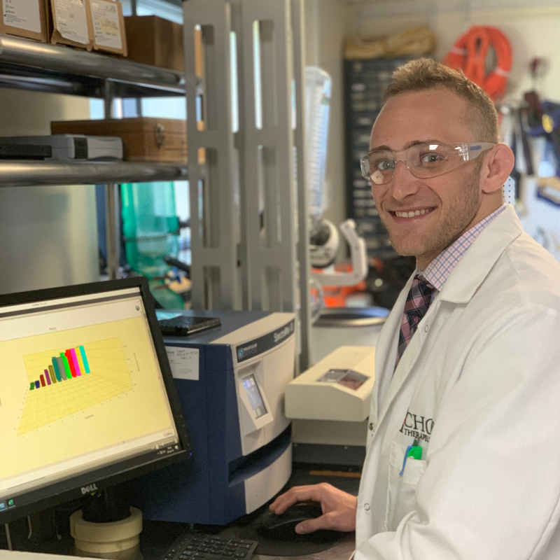Kyle Parella, Graduate Research Assistant, Biochemistry Graduate Student

My research at Ichor involves applying various biophysical methodologies towards small-molecule drug discovery. Numerous diseases originate from pathogenic protein-protein interactions (PPIs)^{[1]}. Disruption of these pathogenic PPIs with small molecules can be an effective therapeutic modality for disease^{[1]}.
Effective characterization of a small molecule’s effect on a given PPI requires many experiments. Executing numerous experiments requires scalable quantities of biologically active protein. Researchers frequently produce human proteins in E.coli because E.coli can provide protein in large quantities, but this is not always the case. E. coli lack the machinery necessary to make certain human proteins properly, resulting in inactive product^{[2]}. This limitation forces researchers to settle with studying small pieces of the protein instead. These small pieces (commonly called fragments) can behave very differently than their native, full-sized counterparts, which can adversely impact research efforts when produced fragments are not physiologically relevant.
Ichor has developed a proprietary protein expression system which frequently allows for barriers commonly encountered in protein production to be overcome. Ichor’s ability to produce full-sized human proteins at scale using this technology enables extensive and otherwise inaccessible insights into certain PPIs. For the past several years the company has applied this technology in the study of various pathways associated with cancer and cellular senescence. My current work involves repurposing this platform for the study of other PPIs thought to be involved in the onset and progression of aging and age-associated diseases.
Citations:
[1] Scott, D.E., Bayly, A.R., Abell, C., and Skidmore, J. (2016). Small molecules, big targets: drug discovery faces the protein–protein interaction challenge. Nature Reviews Drug Discovery 15, 533–550.

[2] Rosano, G.L., and Ceccarelli, E.A. (2014). Recombinant protein expression in Escherichia coli: advances and challenges. Frontiers in Microbiology 5.

